Day 18 – Task 5
Implement and Practice Essential DAX Functions in Power BI

1. Open your existing Power BI report
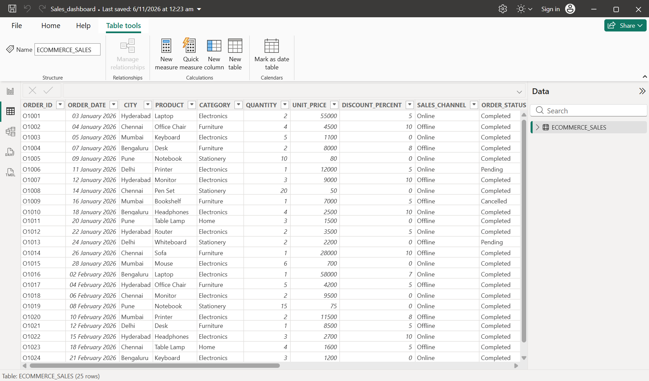
2. Create the Sales Amount column
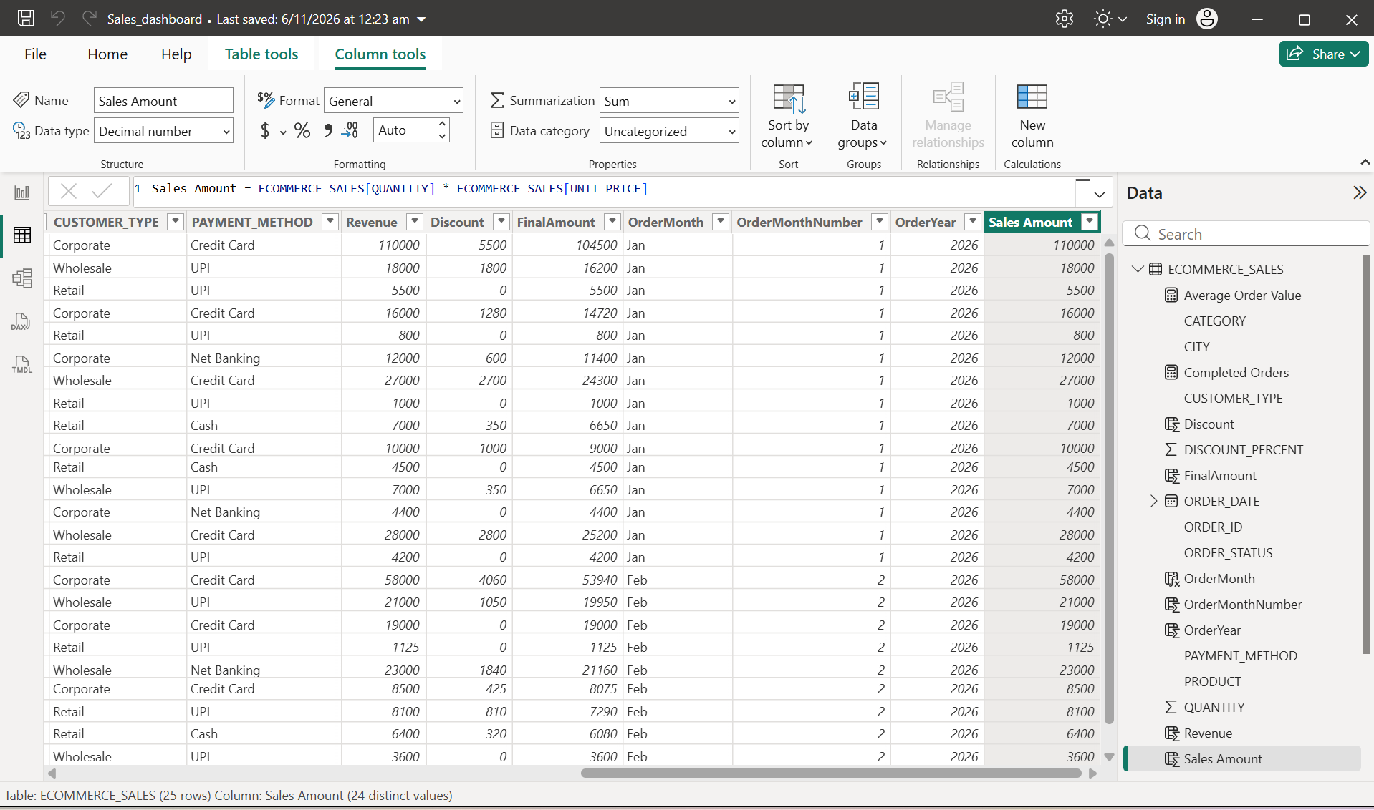

3. Calculate Total Sales using SUM()
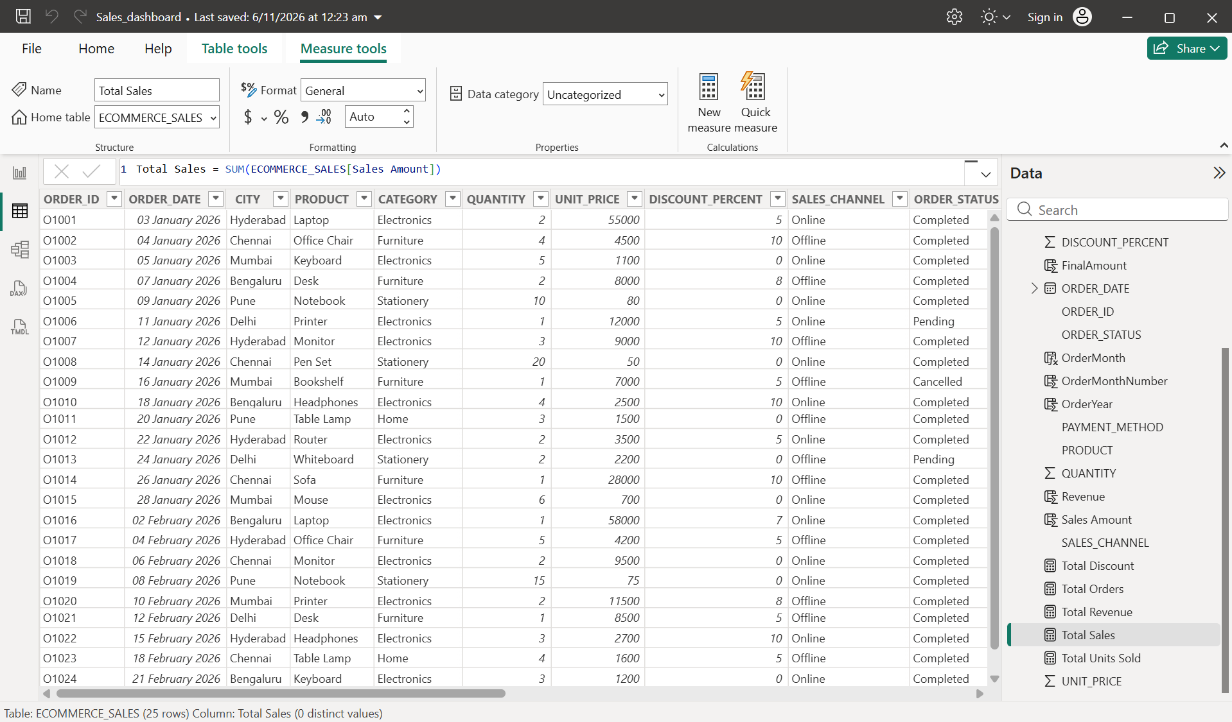

4. Calculate Average Sales using AVERAGE()
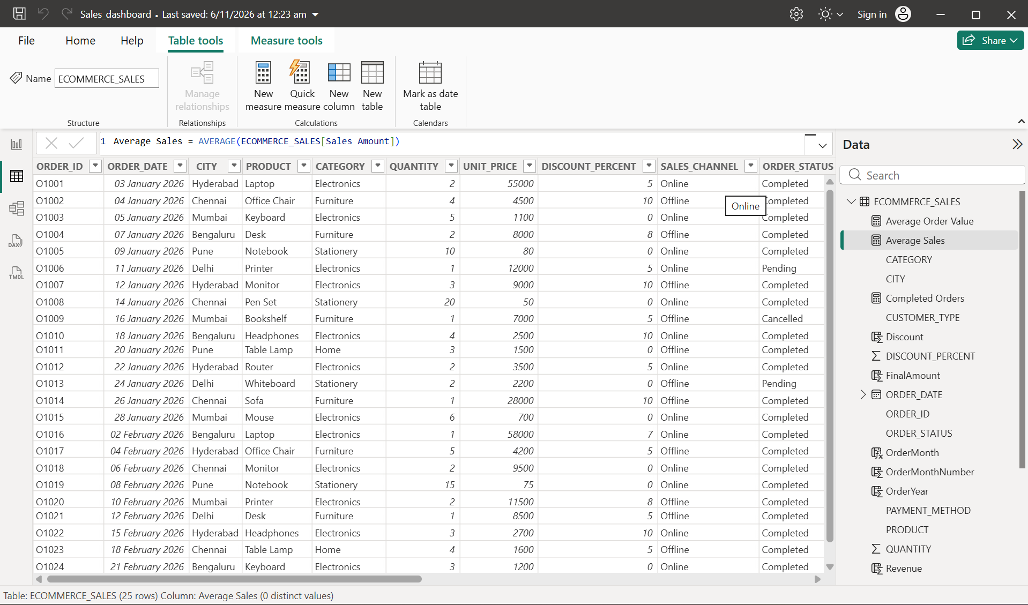

5. Count Transactions using COUNTROWS()
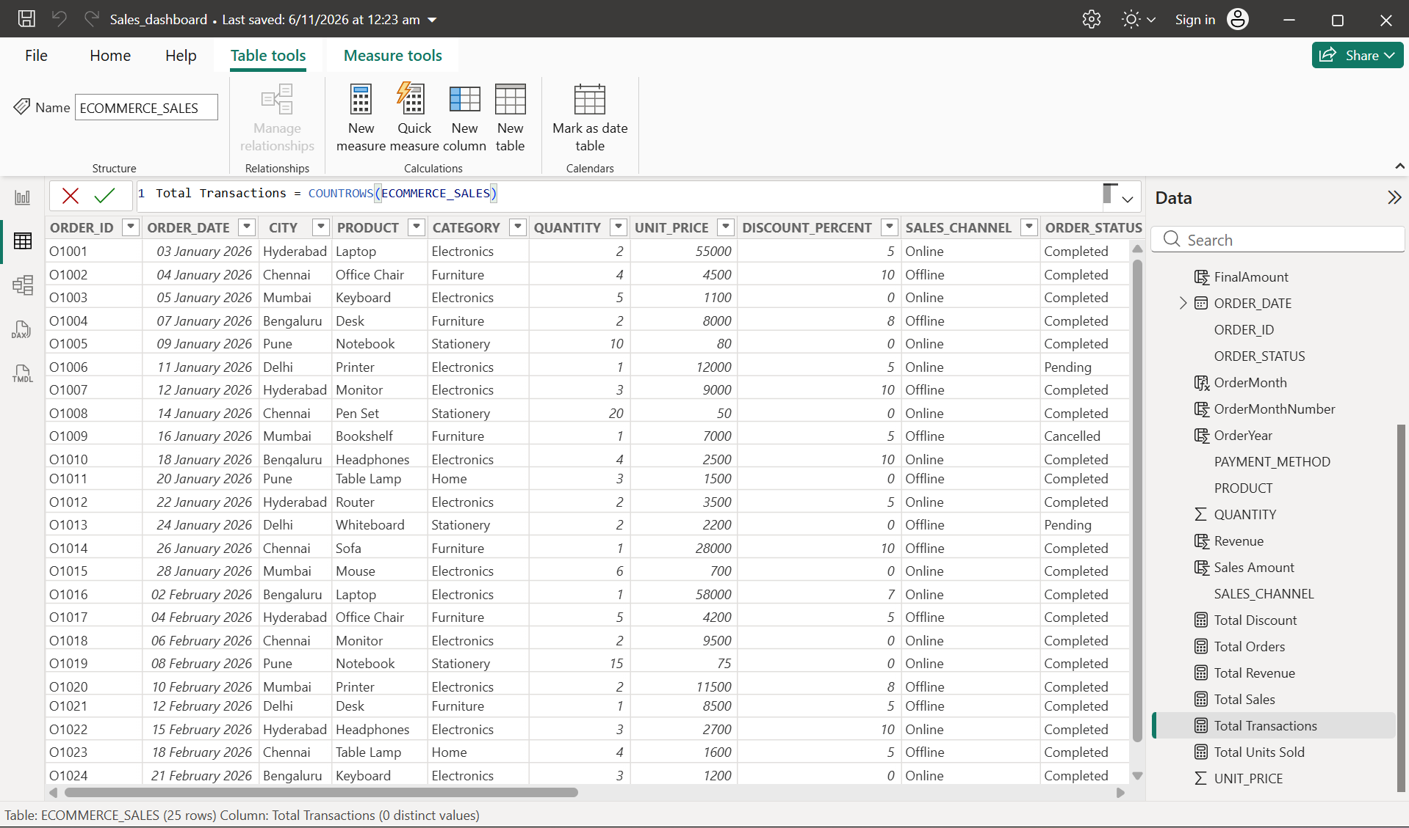

6. Calculate Average Order Value using DIVIDE()
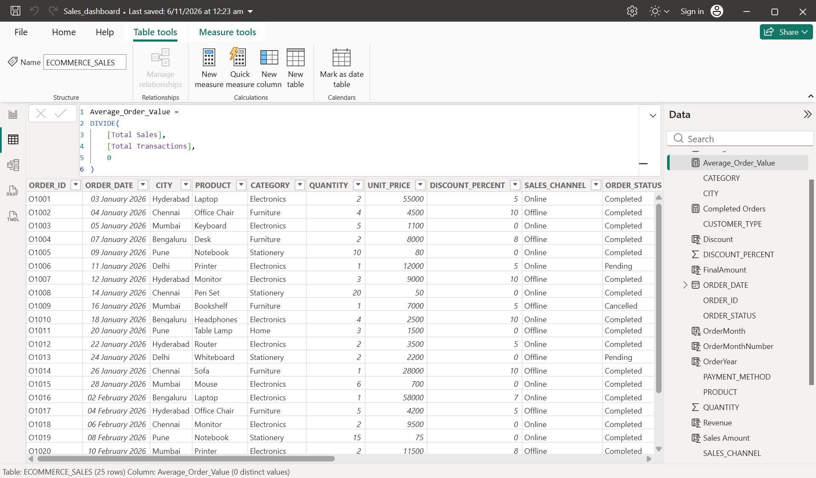

7. Check Sales Target using IF()
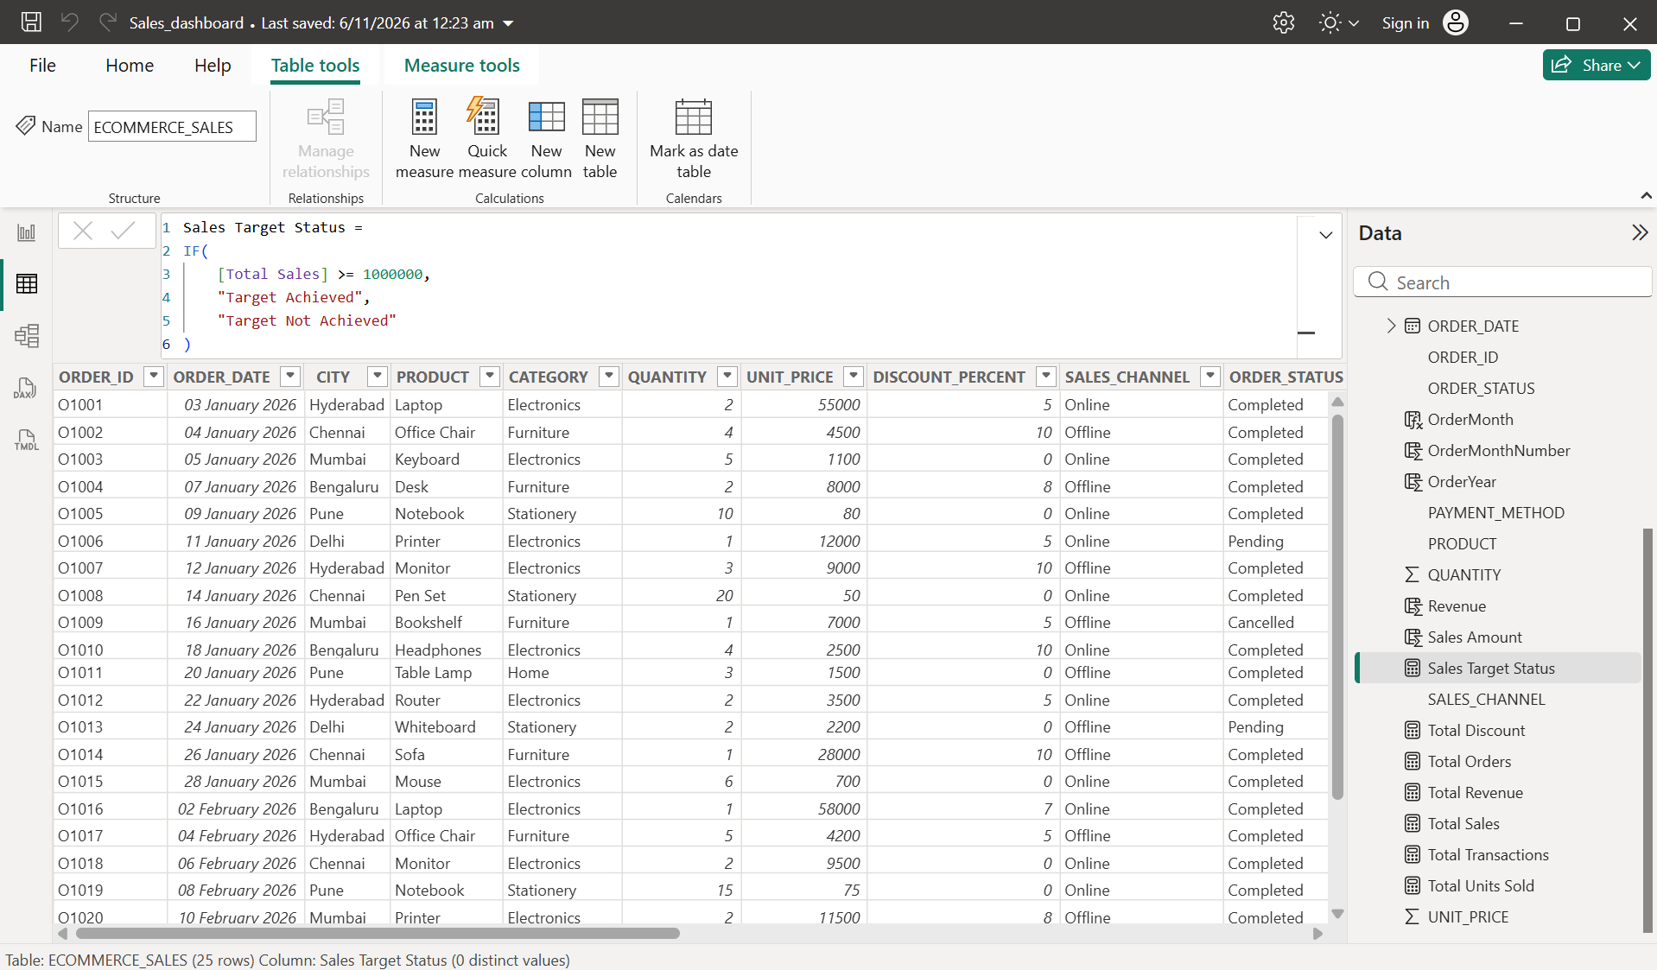

8. Calculate Electronics Sales using CALCULATE()
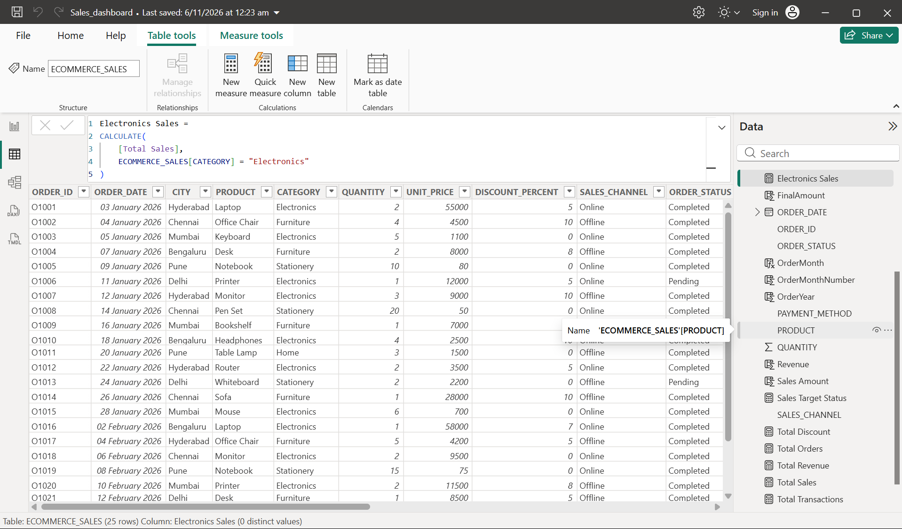

9. Calculate Revenue using SUMX()
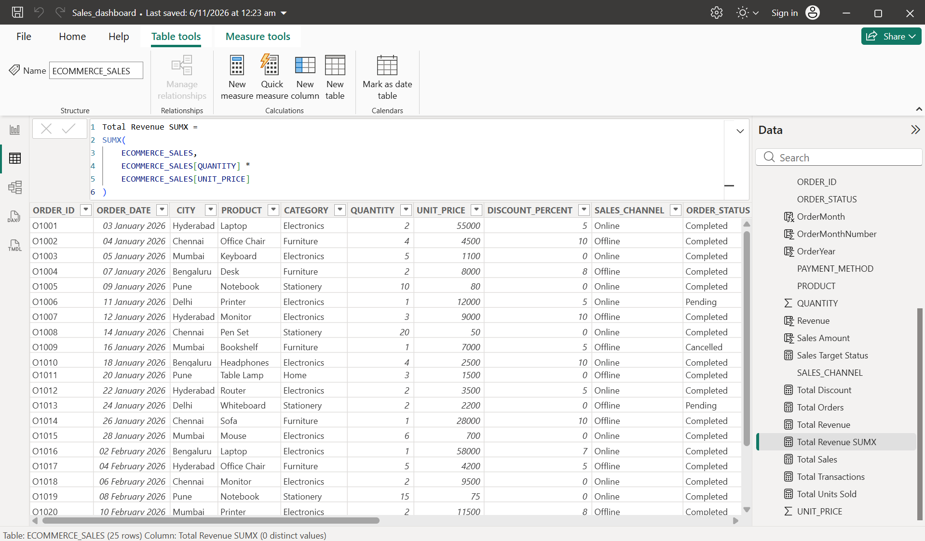

10. Classify Sales using SWITCH()


